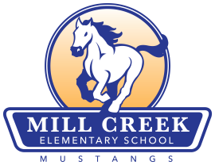
Mill Creek Elementary
School Community Council Agenda
Monday April 28, 2014
Faculty Room 3:40

“Be a Bucket Filler”

- Welcome
- Members in attendance
- Approval of meeting minutes from March 2014 meeting
- Safe Walking Route approval
- Election of new council members for next year
- Miscellaneous Items
- Next meeting: TBA

